**EE 185**

Homework Rubric

horizontal line

Homeworks should be a reflection of your learning and development. They should show careful thought and demonstrate methods learned in class. Rubrics for homework will change throughout the semester to reflect how things like organization should become second nature. Homeworks will be graded on the following scale:

|  |  |  |
| --- | --- | --- |
| **Category** | **Student Score** | **Grader Score** |
| **Organization** | | |
| **Basics** | **1/1** | **/1** |
| **Structure** | **2/2** | **/2** |
| **References** | **1/1** | **/1** |
| **Work** | | |
| **Effort** | **2/2** | **/2** |
| **Clarity** | **2/2** | **/2** |
| **Discussion** | **2/2** | **/2** |
|  |  |  |
| **Total** | **10/10** | **/10** |

**Please fill the Rubric, thoughtfully, and also only load 1 file for the HW**

**Problem 1**

a. What is critical thinking?

Critical thinking is the thinking of thinking that allows for further growth in aspects of learning, retention, and application.

b. Why is important in our lives?

In order to get better in many aspects it is important to step back and see where you are failing or making assumptions.

c. Browse the two links and find 3 items that are of interest to you, read them and provide your notes and reflections on them

It states that the purpose of critical thinking is to limit and reduce plunders. I feel this is because knowing better on how failures occur is more useful than knowing solutions to problems. Solving problems is based on logic and knowing where failures may arise.

**Problem 2**

Your task is to do the following (assuming the ages are integers): Do you think there is enough information to solve for the ages? If you do think there is, solve for the kids’ ages and show your solution. If you do not think it is possible, explain why, and what you need and then explain how you would solve it.

It is not possible to find the ages of the children because you do not have 3 equalities to use to solve for their ages. You would need one more piece of data in order to solve for the ages.

**Problem 3**

1. Read and take notes and include our notes in your report.

There seems to be a lot of focus on subsystems and abstraction rather than specifics on one particular component. In a system diagram it seems that there isn’t much detail at all. Rather it the focus is on the conversion of data, energy, and materials.

2. Please answer the following questions

a. What is the chapter about?

Technological systems and how to break down objects into that view.

b. What are the systems that you saw and found interesting to view the systems level analysis of?

The main system it discusses is the hairdryer, I found it interesting how a simple device such as that could be broken down into subsystems

c. Find something that you like and are interested in, and then apply the chapter's approach to it. Even if you He has done it in the chapter, please find your way add to it and make your systems level diagram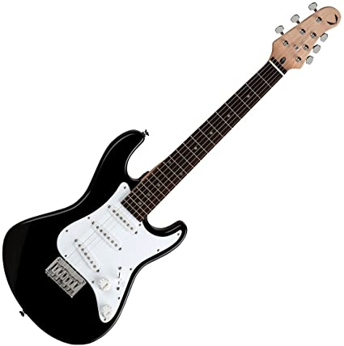.



d. Do you have any suggestion for Prof. Krupczak about this chapter?

No, I feel that this explained very well the aspects of breaking up a system. I would tell him to talk about software and abstraction in the same way such as

Program -> C/C++ -> Assembly -> ….

**Problem 4**

1. How many areas of research are there in the department

5

2. In few sentences describe each area

Bioengineering:

Interfacing hardware with humans or helping with information gathering such as MRI or other sensors.

Cyber Infrastructure:

Networking and embedded systems for computers communicating between each other.

Data, Decisions, Networks and Autonomy

Includes the main aspect of analyzing data and applying it. It also contains machine learning and signal processing.

Energy Infrastructure

The structure behind power lines and efficient power transfer across wires. Also includes the design of stability of the power system in severe conditions.

Materials, Devices, and Circuits

The designing of the circuits and materials that are used. This includes the LED lighting and probably EL as well.

3. Which one of the areas are you interested to know more about and why?

Material, Devices, and Circuits. I feel I am interested in it because it involves many different parts working together and has the most interesting development. It involves many different problem solving such as programming, chemical, and circuit design in order to work more efficiently.

4. What other information would you like to see on this page?

Not that necessary but it would be nice to see